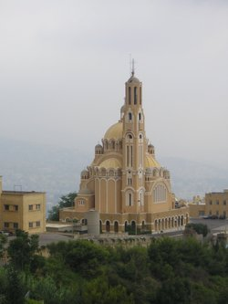

St. Paul Melkite Basilica, Harissa, Lebanon

